[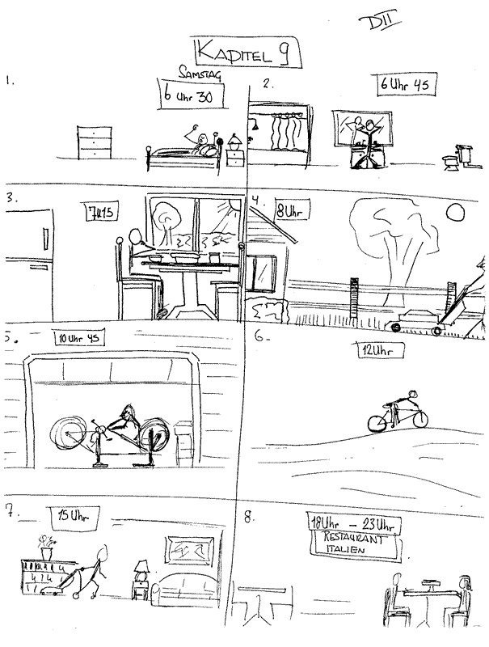](http://www.rockfordschools.org/staff/pickerdb/Wave_Files/DIIKap9_Wave.wav)

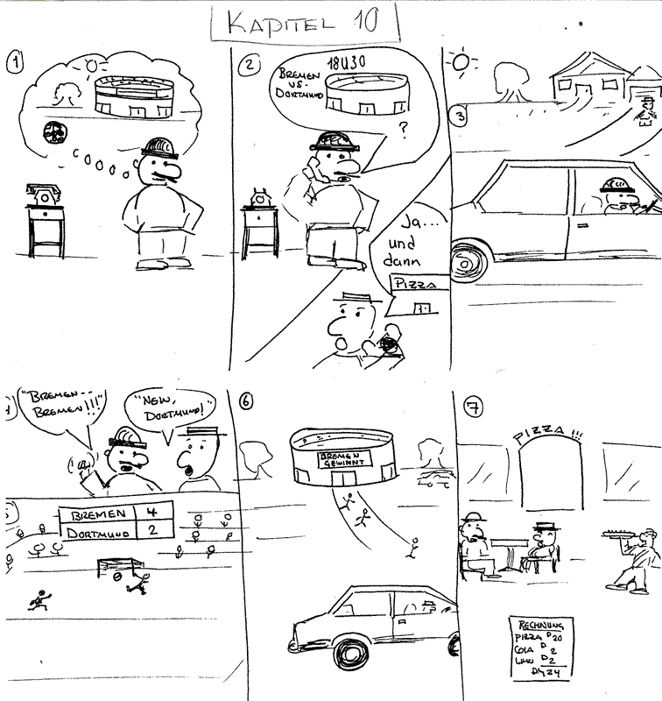

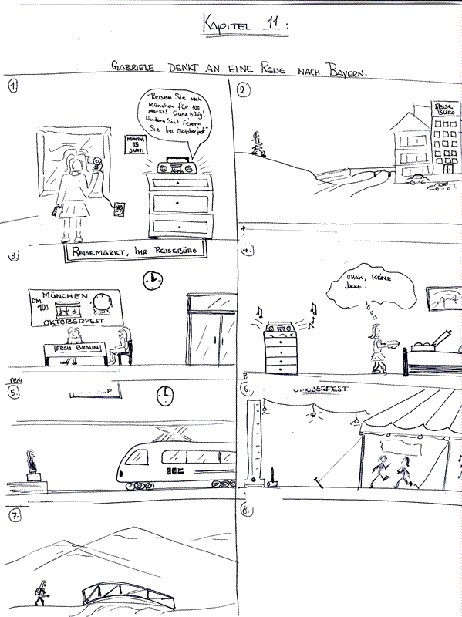

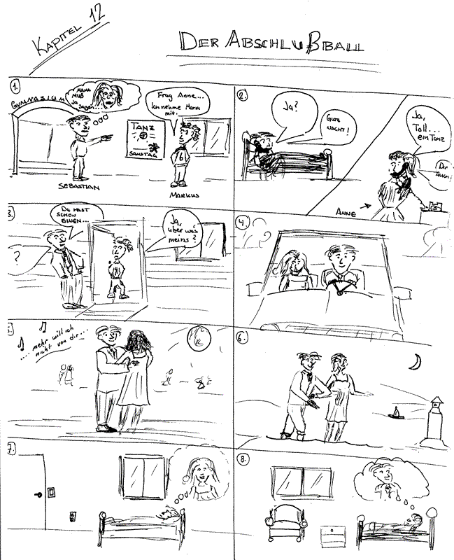

[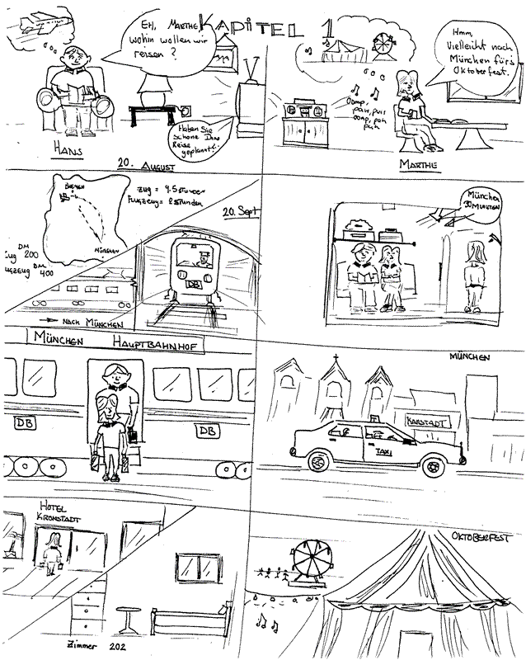](http://www.rockfordschools.org/staff/pickerdb/Wave_Files/DIIKap1_Wave.wav)

[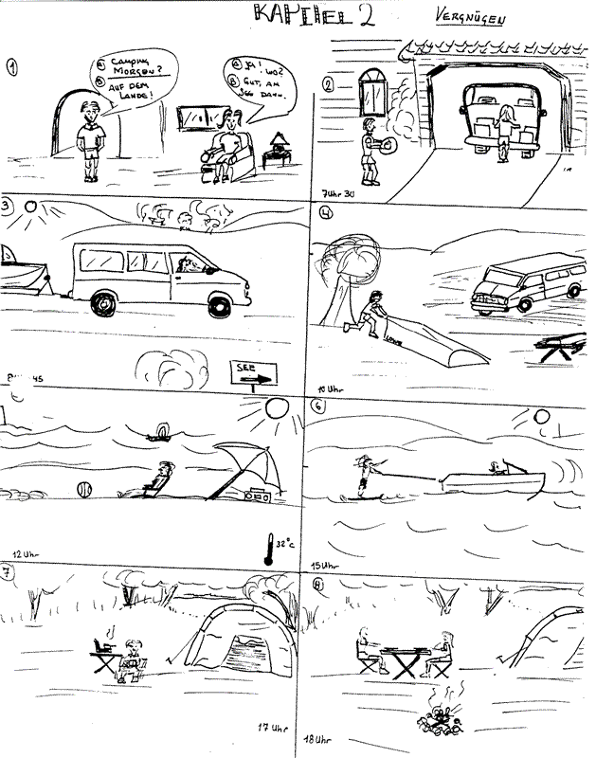](http://www.rockfordschools.org/staff/pickerdb/Wave_Files/DIIKap2_wave.wav)

[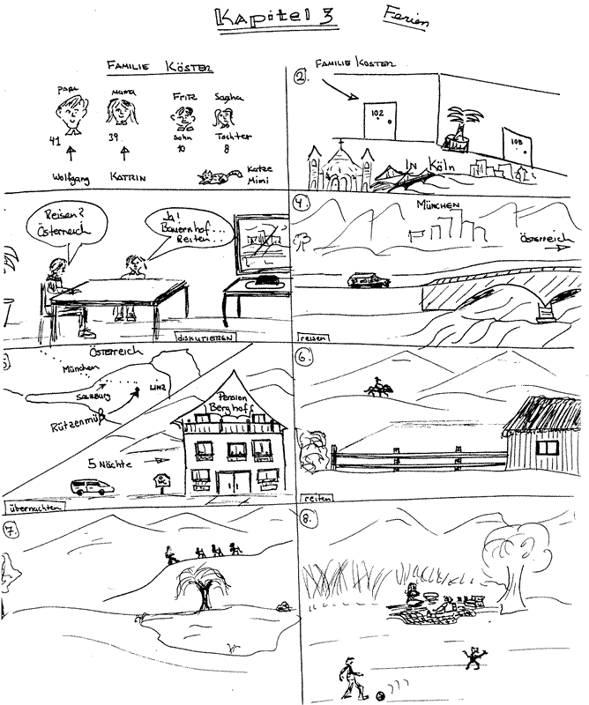](http://www.rockfordschools.org/staff/pickerdb/Wave_Files/kapitel3_wave.wav)

[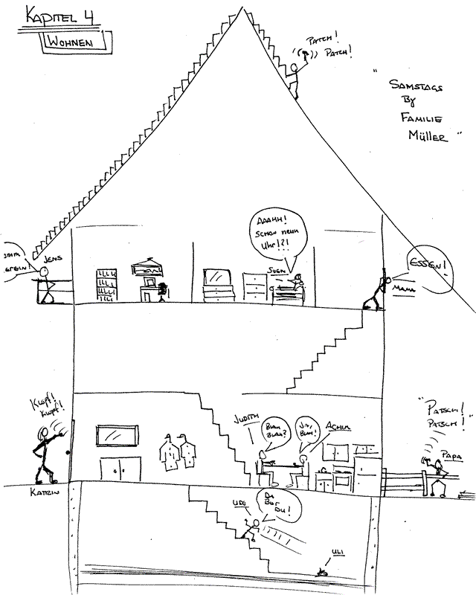](http://www.rockfordschools.org/staff/pickerdb/Wave_Files/Kap4_wave.wav)